Task 1

Pointers :
#include <stdio.h>

int main() {
int age = 27; // Declare an integer variable
int *ptr = &age; // Declare a pointer and store the address of 'age'

printf("Value of age: %d\n", age); // Output: Value of age: 27
printf("Address of age: %p\n", &age); // Output: Address of age: (some memory address)
printf("Value of ptr (address): %p\n", ptr); // Output: Value of ptr (address): (same memory address as &age)
printf("Value pointed to by ptr: %d\n", *ptr); // Output: Value pointed to by ptr: 27
printf("Address of ptr itself: %p\n", (void *)&ptr); // Output: Value pointed to by ptr: 27
return 0;
}
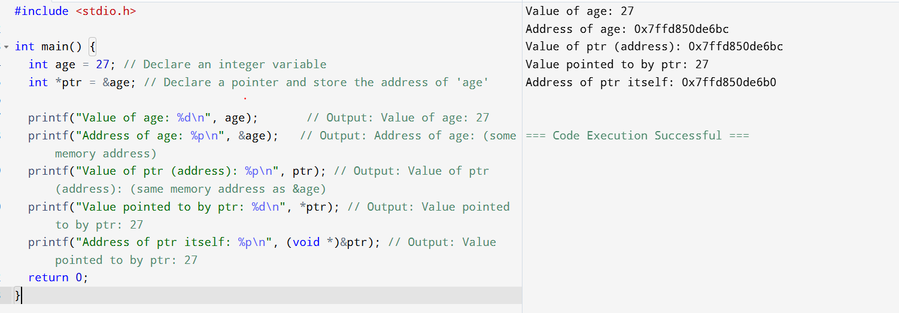

Task 02:

Linked list in c++
#include <iostream>
using namespace std;

// Define a Node class
class Node {
public:
int data; // Data part of the node
Node* next; // Pointer to the next node

// Constructor
Node(int value) : data(value), next(nullptr) {}
};

// Define a Linked List class
class Linkedlist {
private:
Node* head; // Pointer to the head of the list

public:
// Constructor to initialize an empty list
Linkedlist() {
head = nullptr;
}

// Insert a node at the end
void insertAtEnd(int value) {
Node* newNode = new Node(value);
if (head == nullptr) {
head = newNode;
} else {
Node* temp = head;
while (temp->next != nullptr) {
temp = temp->next;
}
temp->next = newNode;
}
}

// Delete a node by value
void deleteByValue(int value) {
if (head == nullptr) return;

if (head->data == value) {
Node* temp = head;
head = head->next;
delete temp;
return;
}

Node* temp = head;
while (temp->next && temp->next->data != value) {
temp = temp->next;
}

if (temp->next) {
Node* nodeToDelete = temp->next;
temp->next = temp->next->next;
delete nodeToDelete;
}
}

// Display the list
void display() {
Node* temp = head;
while (temp != nullptr) {
cout << temp->data << "->";
temp = temp->next;
}
cout << "NULL" << endl;
}

// Destructor to free memory
~Linkedlist() {
Node* temp;
while (head != nullptr) {
temp = head;
head = head->next;
delete temp;
}
}
};

// Main function to demonstrate the list
int main() {
Linkedlist list;

list.insertAtEnd(10);
list.insertAtEnd(20);
list.insertAtEnd(30);

cout << "Linked List: ";
list.display(); // Output: 10->20->30->NULL

list.deleteByValue(20);

cout << "After Deleting 20: ";
list.display(); // Output: 10->30->NULL

return 0;
}

Task 03:

Use the above code to create a Java code which creates a linked list.

// Define a Node class
class Node {
int data; // Data part
Node next; // Pointer to next node

// Constructor
Node(int value) {
data = value;
next = null;
}
}

// Define LinkedList class
class LinkedList {
private Node head; // Head of the list

// Constructor initializes empty list
public LinkedList() {
head = null;
}

// Insert node at the end
public void insertAtEnd(int value) {
Node newNode = new Node(value);

if (head == null) {
head = newNode;
} else {
Node temp = head;
while (temp.next != null) {
temp = temp.next;
}
temp.next = newNode;
}
}

// Delete node by value
public void deleteByValue(int value) {
if (head == null) return;

if (head.data == value) {
head = head.next;
return;
}

Node temp = head;
while (temp.next != null && temp.next.data != value) {
temp = temp.next;
}

if (temp.next != null) {
temp.next = temp.next.next; // Java's GC will collect the unreferenced node
}
}

// Display the list
public void display() {
Node temp = head;
while (temp != null) {
System.out.print(temp.data + "->");
temp = temp.next;
}
System.out.println("NULL");
}
}

// Main class to test the LinkedList
public class LinkedListtestcase {
public static void main(String[] args) {
LinkedList list = new LinkedList();

list.insertAtEnd(10);
list.insertAtEnd(20);
list.insertAtEnd(30);

System.out.print("Linked List: ");
list.display(); // Output: 10->20->30->NULL

list.deleteByValue(20);

System.out.print("After Deleting 20: ");
list.display(); // Output: 10->30->NULL
}
}

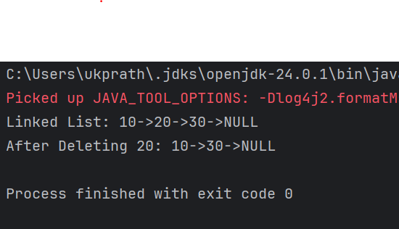

Task 04:

Try to create a node and add a value to it.. Which can take any kind of data in the Node..

- Create a node
11 pax done out of 36 @ 12.38
- Try to add element at the end of the list

- Remove the node

- Display all the elements of the List

11 pax done out of 36 @ 12.48
16 pax at 13.04

- Find size of the linked list

- Index out of bounds

// Generic Node class
class Node<T> {
T data;
Node<T> next;

public Node(T data) {
this.data = data;
this.next = null;
}
}

// Generic LinkedList class
class LinkedList<T> {
private Node<T> head;
private int size;

public LinkedList() {
head = null;
size = 0;
}

// Create and insert at the end
public void insertAtEnd(T value) {
Node<T> newNode = new Node<>(value);

if (head == null) {
head = newNode;
} else {
Node<T> temp = head;
while (temp.next != null) {
temp = temp.next;
}
temp.next = newNode;
}

size++;
}

// Remove node by value
public void deleteByValue(T value) {
if (head == null) return;

if (head.data.equals(value)) {
head = head.next;
size--;
return;
}

Node<T> temp = head;
while (temp.next != null && !temp.next.data.equals(value)) {
temp = temp.next;
}

if (temp.next != null) {
temp.next = temp.next.next;
size--;
}
}

// Display all elements
public void display() {
Node<T> temp = head;
while (temp != null) {
System.out.print(temp.data + " -> ");
temp = temp.next;
}
System.out.println("NULL");
}

// Get size of the linked list
public int getSize() {
return size;
}

// Get element at specific index
public T get(int index) {
if (index < 0 || index >= size) {
throw new IndexOutOfBoundsException("Index " + index + " is out of bounds!");
}

Node<T> temp = head;
int count = 0;
while (count < index) {
temp = temp.next;
count++;
}

return temp.data;
}
}
public class Main {
public static void main(String[] args) {
// Linked list that can hold any type of object
LinkedList<Object> list = new LinkedList<>();

// Create nodes and insert at end
list.insertAtEnd(27); // Integer
list.insertAtEnd("Pratheesh"); // String
list.insertAtEnd(60.38); // Double
list.insertAtEnd(true); // Boolean

System.out.println("List after insertion:");
list.display(); // Output: 11 -> Pratheesh -> 60.38 -> true -> NULL

// Delete node
list.deleteByValue("Pratheesh");
System.out.println("After deleting 'Pratheesh':");
list.display(); // Output: 11 -> 60.38 -> true -> NULL

// Size of the list
System.out.println("Size of list: " + list.getSize()); // Output: 3

// Access valid index
System.out.println("Element at index 1: " + list.get(1)); // Output: 60.38

// Access invalid index
try {
System.out.println("Element at index 5: " + list.get(5));
} catch (IndexOutOfBoundsException e) {
System.out.println("Error: " + e.getMessage());
}
}
}

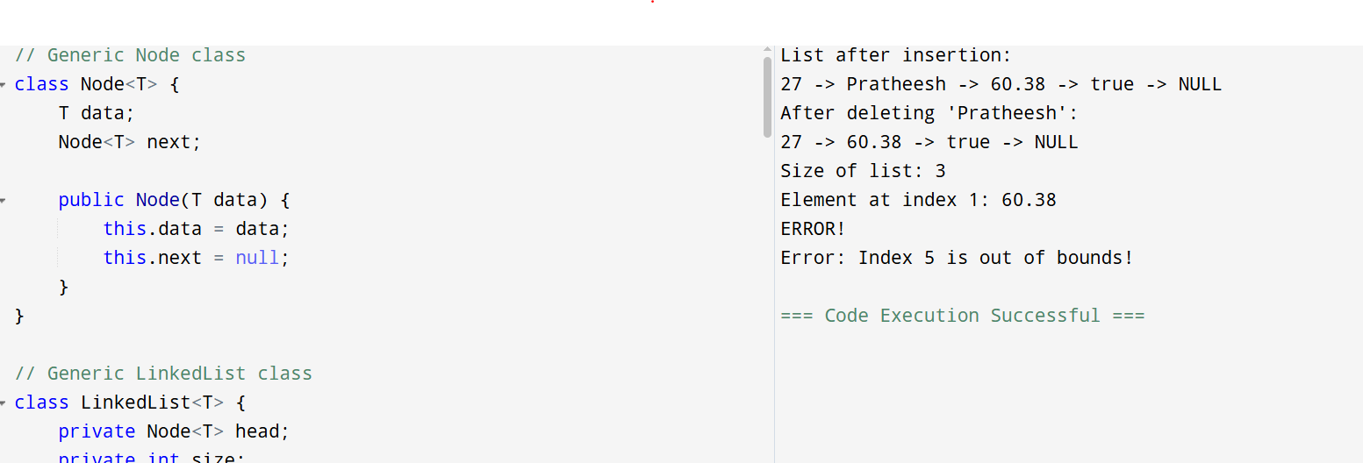

Task 05:

List down all the methods of Linked list

Common LinkedList Methods

🔹 Adding Elements
- add(E e) – Adds to the end.
- add(int index, E element) – Inserts at specific index.
- addFirst(E e) – Adds to the beginning.
- addLast(E e) – Adds to the end.
- offer(E e) – Adds to the end (returns boolean).
- offerFirst(E e) – Adds to the beginning.
- offerLast(E e) – Adds to the end.

🔹 Accessing Elements
- get(int index) – Gets element at index.
- getFirst() – Gets first element.
- getLast() – Gets last element.
- peek() – Retrieves head without removing.
- peekFirst() – Retrieves first without removing.
- peekLast() – Retrieves last without removing.

🔹 Updating Elements
- set(int index, E element) – Replaces the element at index.

🔹 Removing Elements
- remove() – Removes head.
- remove(int index) – Removes element at index.
- remove(Object o) – Removes first occurrence.
- removeFirst() – Removes first element.
- removeLast() – Removes last element.
- poll() – Retrieves and removes head.
- pollFirst() – Retrieves and removes first.
- pollLast() – Retrieves and removes last.
- clear() – Removes all elements.

🔹 Searching
- contains(Object o) – Checks if list contains element.
- indexOf(Object o) – First index of element.
- lastIndexOf(Object o) – Last index of element.
- isEmpty() – Checks if list is empty.
- size() – Returns number of elements.

🔹 Iteration
- iterator() – Returns an iterator.
- descendingIterator() – Reverse-order iterator.
- listIterator() – List iterator over elements.
- listIterator(int index) – List iterator starting at index.

Task 6
import java.util.LinkedList;

public class task06 {
public static void main(String[] args) {
// Create LinkedList of strings
LinkedList<String> fruits = new LinkedList<>();

// Add elements to the list
fruits.add("Apple");
fruits.add("Banana");
fruits.add("Mango");
fruits.add("Orange");

// Display the list
System.out.println("Fruits List: " + fruits);

// Add at first and last
fruits.addFirst("Pineapple");
fruits.addLast("Grapes");

System.out.println("After adding first and last: " + fruits);

}
}

Task7

import java.util.LinkedList;

public class task07 {
public static void main(String[] args) {
// Create LinkedList of strings
LinkedList<String> fruits = new LinkedList<>();

// Add elements to the list
fruits.add("Apple");
fruits.add("Banana");
fruits.add("Mango");
fruits.add("Orange");

// Display the list
System.out.println("Fruits List: " + fruits);

// Add at first and last
fruits.addFirst("Pineapple");
fruits.addLast("Grapes");

System.out.println("After adding first and last: " + fruits);

// Removing the first element
fruits.removeFirst();

// Removing the last element
fruits.removeLast();

// Displaying the updated LinkedList
System.out.println("After removing first and last: " + fruits);
}
}

Task 8

import java.util.LinkedList;

public class task08 {
public static void main(String[] args) {
// Create LinkedList of strings
LinkedList<String> fruits = new LinkedList<>();

// Add elements to the list
fruits.add("Apple");
fruits.add("Banana");
fruits.add("Mango");
fruits.add("Orange");

// Display the list
System.out.println("Fruits List: " + fruits);

// Add at first and last
fruits.addFirst("Pineapple");
fruits.addLast("Grapes");

System.out.println("After adding first and last: " + fruits);

// Removing the first element
fruits.removeFirst();

// Removing the last element
fruits.removeLast();

// Displaying the updated LinkedList
System.out.println("After removing first and last: " + fruits);
// Updating the first element
fruits.set(1, "Pineapple");

// Displaying the updated list
System.out.println("Updated list: " + fruits);
}
}

Task09
display the list twice 1..... with get method in for loop and 2 ... for each loop

import java.util.LinkedList;

public class task09 {
public static void main(String[] args) {
// Creating and populating LinkedList
LinkedList<String> fruits = new LinkedList<>();
fruits.add("Apple");
fruits.add("Banana");
fruits.add("Mango");
fruits.add("Orange");

// 1. Display using get() and for loop
System.out.println("Displaying using get() and for loop:");
for (int i = 0; i < fruits.size(); i++) {
System.out.println(fruits.get(i));
}

// 2. Display using for-each loop
System.out.println("\nDisplaying using for-each loop:");
for (String fruit : fruits) {
System.out.println(fruit);
}
}
}

Task 10: display the elements of the linked list with out loops

import java.util.LinkedList;

public class task010 {
public static void main(String[] args) {
// Create and populate the LinkedList
LinkedList<String> fruits = new LinkedList<>();
fruits.add("Apple");
fruits.add("Banana");
fruits.add("Mango");
fruits.add("Orange");

// Display the LinkedList without using loops
System.out.println("LinkedList elements: " + fruits);
}
}

task 11: convert the linked list to an array and display Hint : Object[] a = llobj.toArray();

import java.util.LinkedList;
import java.util.Arrays;

public class task011 {
public static void main(String[] args) {
// Create and populate the LinkedList
LinkedList<String> fruits = new LinkedList<>();
fruits.add("Apple");
fruits.add("Banana");
fruits.add("Mango");
fruits.add("Orange");

// Convert LinkedList to array
Object[] fruitArray = fruits.toArray();
System.out.println(Arrays.toString(fruitArray));

// Display the array elements
System.out.println("Elements in array form:");
for (Object fruit : fruitArray) {
System.out.println(fruit);
}
}
}

Task012
import java.util.LinkedList;

public class task012 {
public static void main(String[] args) {
// Create and populate the original LinkedList
LinkedList<String> fruits = new LinkedList<>();
fruits.add("Apple");
fruits.add("Banana");
fruits.add("Mango");

// Clone the LinkedList
LinkedList<String> clonedList = (LinkedList<String>) fruits.clone();

// Display original and cloned lists
System.out.println("Original LinkedList: " + fruits);
System.out.println("Cloned LinkedList: " + clonedList);
System.out.println("Same object? " + (fruits == clonedList));
}
}

Task013

import java.util.LinkedList;

public class task013 {
public static void main(String[] args) {
// Create and populate a LinkedList
LinkedList<String> fruits = new LinkedList<>();
fruits.add("Banana");
fruits.add("Mango");
fruits.add("Orange");

System.out.println("Original List: " +fruits);
// Use push() to add an element at the front (like stack)
fruits.push("Apple"); // Same as addFirst()

System.out.println("After push: " + fruits); // [Apple, Banana, Mango, Orange]

// Use pop() to remove the first element (like stack)
String popped = fruits.pop(); // Removes "Apple"

System.out.println("Popped element: " + popped);
System.out.println("After pop: " + fruits); // [Banana, Mango, Orange]
}
}

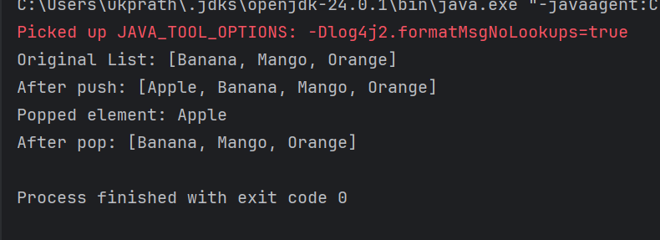
Task 14:
Splititerator
import java.util.LinkedList;
import java.util.Spliterator;

import java.util.*;
public class task014 {
public static void main(String[] args) {

LinkedList<String> l = new LinkedList<>();

l.add("Pratheesh");
l.add(".K");
l.add("BE");
l.add("MBA");

System.out.println(l);

Spliterator<String> it = l.spliterator();

System.out.println("Splitting the list:");
it.forEachRemaining(System.out::println);
}
}
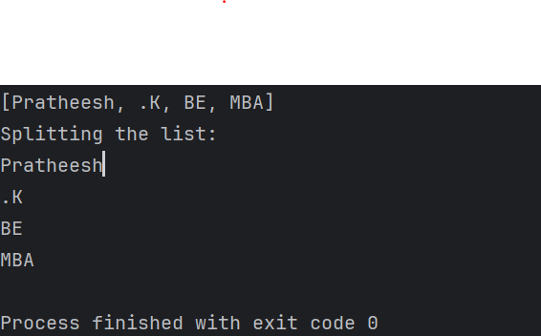

Task 15:
tryAdvance()
import java.util.LinkedList;
import java.util.Spliterator;

public class task015 {
public static void main(String[] args) {
LinkedList<String> llobj = new LinkedList<>();
llobj.add("Pratheesh");
llobj.add("K");
llobj.add("BE");
llobj.add("MBA");

Spliterator<String> itobj1 = llobj.spliterator();
Spliterator<String> itobj2 = itobj1.trySplit();

System.out.println("Spliterator 1:");
while (itobj1 != null && itobj1.tryAdvance(n -> System.out.println(n)));

System.out.println("Spliterator 2:");
while (itobj2 != null && itobj2.tryAdvance(n -> System.out.println(n)));
}
}

Task 16:
Create a doubly linked list..
public class DoublyLinkedList {
// Node structure
private static class Node {
int data;
Node prev;
Node next;

Node(int d) {
data = d;
}
}

private Node head;
private Node tail;

// Add at beginning
public void insertAtBeginning(int data) {
Node node = new Node(data);
if (head == null) {
head = tail = node;
} else {
node.next = head;
head.prev = node;
head = node;
}
}

// Add at end
public void insertAtEnd(int data) {
Node node = new Node(data);
if (tail == null) {
head = tail = node;
} else {
tail.next = node;
node.prev = tail;
tail = node;
}
}

// Insert at specific position (1-based index)
public void insertAtPosition(int data, int position) {
if (position <= 1 || head == null) {
insertAtBeginning(data);
return;
}
Node current = head;
int idx = 1;
while (current.next != null && idx < position - 1) {
current = current.next;
idx++;
}
if (current.next == null) {
insertAtEnd(data);
} else {
Node node = new Node(data);
node.next = current.next;
node.prev = current;
current.next.prev = node;
current.next = node;
}
}

// Delete node at specific position (1-based index)
public void deleteAtPosition(int position) {
if (head == null) return;
if (position == 1) {
if (head == tail) {
head = tail = null;
} else {
head = head.next;
head.prev = null;
}
return;
}
Node current = head;
int idx = 1;
while (current != null && idx < position) {
current = current.next;
idx++;
}
if (current == null) return;
if (current == tail) {
tail = tail.prev;
tail.next = null;
} else {
current.prev.next = current.next;
current.next.prev = current.prev;
}
}

// Traverse forward
public void traverseForward() {
Node n = head;
while (n != null) {
System.out.print(n.data + " ");
n = n.next;
}
System.out.println();
}

// Traverse backward
public void traverseBackward() {
Node n = tail;
while (n != null) {
System.out.print(n.data + " ");
n = n.prev;
}
System.out.println();
}

// Sample usage
public static void main(String[] args) {
DoublyLinkedList dll = new DoublyLinkedList();
dll.insertAtEnd(10);
dll.insertAtEnd(20);
dll.insertAtBeginning(5);
dll.insertAtPosition(15, 3);
dll.traverseForward(); // 5 10 15 20
dll.traverseBackward(); // 20 15 10 5
dll.deleteAtPosition(2);
dll.traverseForward(); // 5 15 20
}
}

Task 17:
Create a Hash MAp of capacity 10.
Hint:
HashMap<String, Integer> hm2 = new HashMap<String, Integer>(10);
import java.util.HashMap;

public class task017 {
public static void main(String[] args) {
// Creating a HashMap with initial capacity of 10
HashMap<String, Integer> hm = new HashMap<String, Integer>(10);

// Adding some elements to the HashMap
hm.put("One", 1);
hm.put("Two", 2);
hm.put("Three", 3);

// Printing the HashMap
System.out.println("HashMap with capacity 10: " + hm);

// You can also check the size of the HashMap
System.out.println("Current size of HashMap: " + hm.size());
}
}
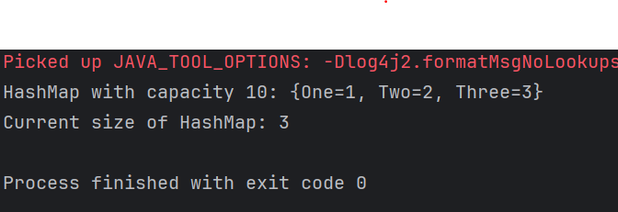

Task 18:
Copy data from one map to another map.

hint:

HashMap<String, Integer> hm3 = new HashMap<String, Integer>( hm2);
import java.util.HashMap;

public class task018 {
public static void main(String[] args) {
// Original map
HashMap<String, Integer> hm2 = new HashMap<>();
hm2.put("Apple", 10);
hm2.put("Banana", 20);
hm2.put("Mango", 30);

// Copy data from hm2 to hm3 using constructor
HashMap<String, Integer> hm3 = new HashMap<>(hm2);

// Display the copied map
System.out.println("Original Map (hm2): " + hm2);
System.out.println("Copied Map (hm3): " + hm3);
}
}
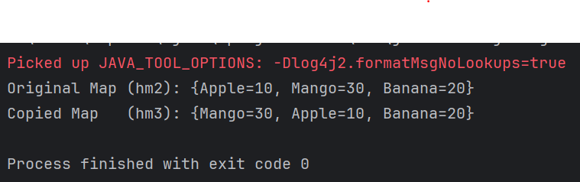

Task 19:

Create a hash map using a lod factor

Hint:

HashMap<String, Integer> hm4= new HashMap<String, Integer>(10, 0.75f);

Initial capacity ===10
Load factor === 0.75f

import java.util.HashMap;

public class task019 {
public static void main(String[] args) {
// Create HashMap with initial capacity 10 and load factor 0.75
HashMap<String, Integer> hm = new HashMap<String, Integer>(10, 0.75f);

// Calculate threshold
int initialCapacity = 10;
float loadFactor = 0.75f;
int threshold = (int)(initialCapacity * loadFactor);

System.out.println("Initial Configuration:");
System.out.println("Initial Capacity: " + initialCapacity);
System.out.println("Load Factor: " + loadFactor);
System.out.println("Threshold before rehashing: " + threshold);

// Adding elements to HashMap
System.out.println("\nAdding elements to HashMap:");

hm.put("One", 1);
System.out.println("Added One: " + hm.size() + " elements");

hm.put("Two", 2);
System.out.println("Added Two: " + hm.size() + " elements");

hm.put("Three", 3);
System.out.println("Added Three: " + hm.size() + " elements");

hm.put("Four", 4);
System.out.println("Added Four: " + hm.size() + " elements");

hm.put("Five", 5);
System.out.println("Added Five: " + hm.size() + " elements");

hm.put("Six", 6);
System.out.println("Added Six: " + hm.size() + " elements");

hm.put("Seven", 7);
System.out.println("Added Seven: " + hm.size() + " elements");

// After threshold (7.5), HashMap will rehash
hm.put("Eight", 8);
System.out.println("Added Eight: " + hm.size() + " elements (Rehashing may occur)");

// Display final HashMap
System.out.println("\nFinal HashMap contents:");
for(String key : hm.keySet()) {
System.out.println("Key: " + key + ", Value: " + hm.get(key));
}

// HashMap operations
System.out.println("\nHashMap Operations:");
System.out.println("Size of HashMap: " + hm.size());
System.out.println("Contains key 'Three'? " + hm.containsKey("Three"));
System.out.println("Value for key 'Four': " + hm.get("Four"));
}
}
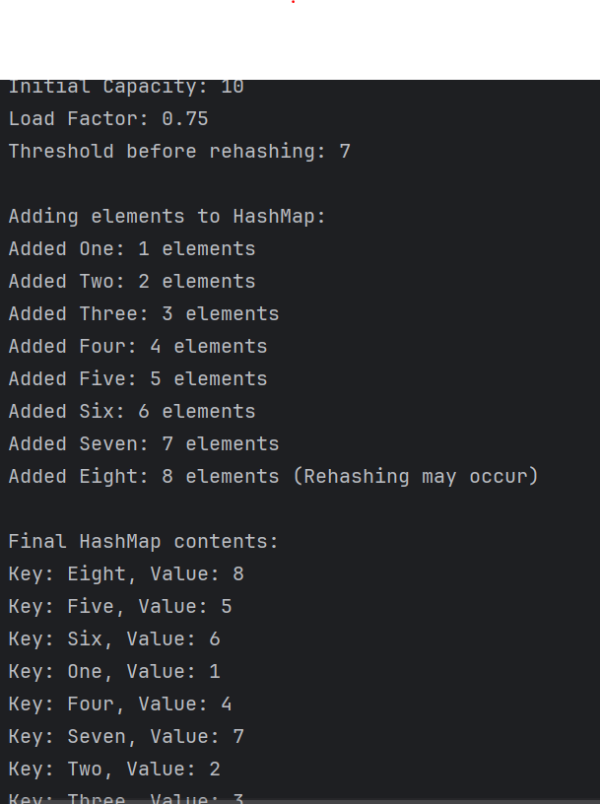

Task020_DS_HashMapCreateMethods:

Different methods to create a hashmap in java :
1) Constructing a hashmap with default capacity

ex:
HashMap<String, Integer> hm1 = new HashMap<String, Integer>();

2) Constructing a hashmap with a capacity 10

ex:
HashMap<String, Integer> hm2 = new HashMap<String, Integer>(10);

3)copy one map to another map

ex:
HashMap<String, Integer> hm3 = new HashMap<String, Integer>( hm2);

4)
Specifying load factor along with the capacity

ex:
HashMap<String, Integer> hm4= new HashMap<String, Integer>(10, 0.75f);

Initial capacity ===10
Load factor === 0.75f

Task 21

public class CircularLinkedList {
// Node class
class Node {
int data;
Node next;

public Node(int data) {
this.data = data;
this.next = null;
}
}

private Node head = null;
private Node tail = null;

// Method to add a node to the circular linked list
public void addNode(int data) {
Node newNode = new Node(data);

// If list is empty
if (head == null) {
head = newNode;
tail = newNode;
newNode.next = head; // Make it circular
} else {
tail.next = newNode; // Add new node after tail
tail = newNode; // Make new node as tail
tail.next = head; // Connect tail to head
}
}

// Method to display the circular linked list
public void display() {
if (head == null) {
System.out.println("Circular Linked List is empty");
return;
}

Node current = head;
System.out.print("Circular Linked List: ");
do {
System.out.print(current.data + " -> ");
current = current.next;
} while (current != head);
System.out.println("(back to head)");
}

// Method to count nodes in the circular linked list
public int countNodes() {
if (head == null) return 0;

int count = 0;
Node current = head;
do {
count++;
current = current.next;
} while (current != head);

return count;
}

public static void main(String[] args) {
CircularLinkedList cll = new CircularLinkedList();

// Adding nodes
cll.addNode(1);
cll.addNode(2);
cll.addNode(3);
cll.addNode(4);
cll.addNode(5);

// Display the list
cll.display();

// Display count of nodes
System.out.println("Number of nodes: " + cll.countNodes());

// Demonstrate circular nature
System.out.println("\nDemonstrating circular nature (10 iterations):");
Node current = cll.head;
for(int i = 0; i < 10; i++) {
System.out.print(current.data + " ");
current = current.next;
}
}
}

